ROZELLE PUBLIC SCHOOL P&C UNIFORM SHOP INFORMATION for 2019
Please ensure students wear full school uniform every day to school. There are a range of options for your child, to ensure that they feel comfortable at school.
Hats: As part of our school uniform policy all students are required wear a school RPS hat while outside and on school excursions. The wearing of a school hat is an important aspect of keeping your child sun safe at school. Students without a hat will be asked to play in the undercover COLA area. Please make sure there is a labelled hat in your child’s bag each day, as this is the most common item to go missing.
Labelling: Please label all of your child’s belongings. Each item of clothing has a tag for labelling. You can also use a marker to label on the inside of clothing.
Items in the playground are returned to the lost property box. The lost property box is located outside the school office. The school office sorts this periodically, and returns labelled items to the children’s classrooms. Any unidentified clothing is donated to the second hand section of the uniform shop.
What to order: Uniforms are available in even sizes only, and are standard sizes. The majority of children starting Kindergarten will wear size 4 or 6 but there are some size 3 shorts and pants available on request. Netball skirts and skorts are smaller than standard sizes and sports shorts are larger.
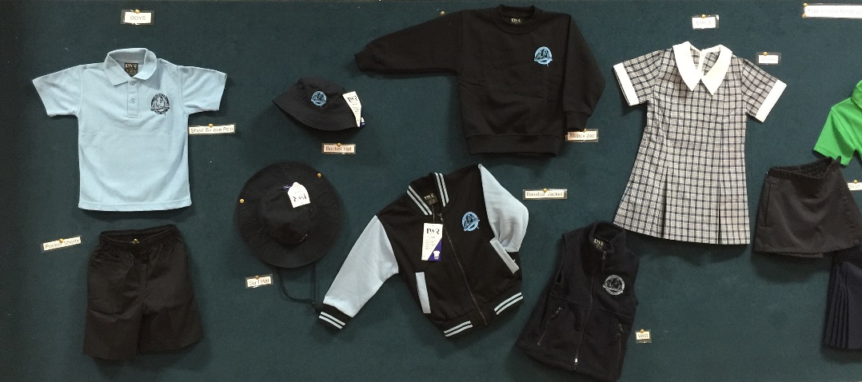
Sports: Your child’s teacher will advise your child’s sports day, house name and colour during Term 1. If you have older siblings at the school they will have the same house team. Sports uniform is generally worn one day a week with sports shoes.
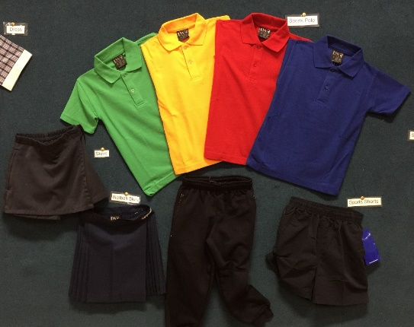
Fairtrade shirts: The school community voted to change the supplier of our short sleeved polo shirts to a GOTS certified fair trade 100% organic cotton company. We were one of the first schools in Sydney to use these as a part of our uniform. You can read more about these at https://www.rrepp.com.au/.
How to Purchase Rozelle Public School Uniforms
- Kindy starter packs are available for purchase during the Kindergarten Transition Program in the school Hall, using a credit card (Visa, MasterCard, AMEX or Apple Pay) with a $1 surcharge. The packs are not discounted. There will be an information stand for advice and sizing purposes. An electronic receipt will be provided, so items can be returned or exchanged. Please check your order before leaving the hall.

The Shorts Pack - Green The Dress Pack - Gold
1 x Backpack 1 x Backpack
2 x Surf hats 2 x Surf hats
2 x Pocket shorts 1 x Short sleeve Dress
1 x Sports short 2 x Short sleeve tshirts
3 x Short sleeve tshirts 1 x Box pleat skirt
1 x skort
PRICE $200 PRICE $212
There are 2 different sizes for the packs; Size4 and Size6. Both pack sizes will be supplied with the Surf Hat size S 55cm. Hats may be swapped if they are not the right size or style for your child. The hats are all the same price.
- Orders can be placed online using our service provider Flexischools. Register at www.flexischools.com.au.
Step 1: Click the REGISTER button.
Step 2: Enter your email to create an account.
Step 3: You will be emailed a link to an online form - follow the link.
Step 4: Choose a username and password and complete the form.
Step 5: Add each student and their class as ‘New Starter’
Step 6: Top-up the account - VISA, Mastercard, Paypal or Direct Deposit. (but not bpay).

During Kindy Transition the additional collection points of ‘Preschool’ or ‘Transition’ will be offered. If you choose ‘Transition’ as your delivery option and order by 5:30pm on Monday, the order will be ready for pickup on Wednesday morning in the school hall at the next Kindy orientation. Please be prepared to show ID and check your order when you pick it up.
During term time your order can be delivered to OOSH or picked up from the school office. Ordering online is recommended at the beginning of the school year, when the shop is very busy. Flexischools is also used for canteen and other school events run by the P&C.
- The uniform shop is located in the back of the school hall, in the same room as the canteen. Opening times are Tuesdays and Fridays 8.45am – 9.15am. Payment in the uniform shop is by cash, credit card (Visa, MasterCard, AMEX or Apple Pay) or cheque payable to ‘Rozelle Public School P&C’. A $1 surcharge is applicable to card payments. Second hand items are available from the shop, not online. Please consider donating uniform in good condition once your child has outgrown it.
All items can be exchanged or refunded after purchase provided that they are in new condition ie; have not been worn, washed or labelled.
The Rozelle uniform shop is staffed entirely by parent volunteers who provide this service for all parents at the school. The shop is not run for profit, and any proceeds go back into the school for resources and facilities. Please email rozelleuniformshop@gmail.com with any queries or comments.

